‘BOOKLET’
How to arrive to STUK?
Where to stay?

Contents
1 STUK (Radiation and Nuclear Safety Authority) 1
2 Hotels 2
2.1 Hotels in Tikkurila 2
2.2 Hotels in Helsinki City Centre 3
3 Other information 3
3.1 Helsinki Airport 3
3.1.1 Taxi services at Helsinki Airport 3
3.2 Transports 3
3.2.1 From the Airport to Tikkurila 3
3.2.2 From Tikkurila to Airport 4
3.2.3 From Tikkurila to Helsinki City Centre 4
3.2.4 General info on travelling with the HSL-area (Helsinki, Vantaa, Espoo and several other surrounding cities) 4
3.3 Restaurants and shops 5
3.4 Emergency and Health care 5
3.5 COVID-19 5
3.6 Currency 5
3.7 Electricity 6
3.8 Pharmacies 6
3.9 Drinking water 6
3.10 Weather 6

STUK (Radiation and Nuclear Safety Authority)
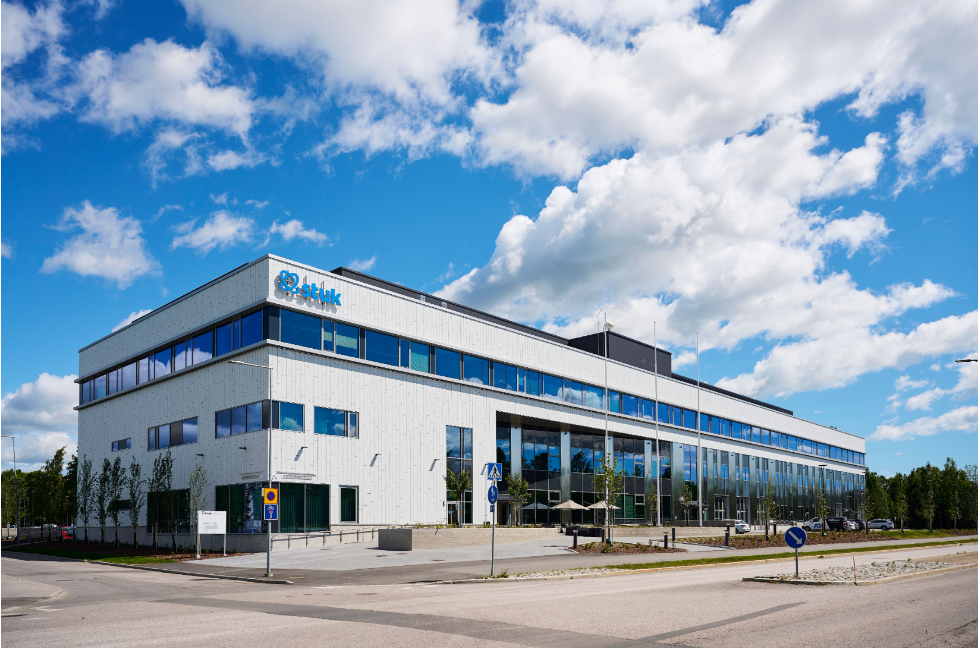

Address: Jokiniemenkuja 1, Vantaa (The main entrance is in address Jokiniemenkatu 28.)  Tel: +358 9 759 881  Open: Mon-Fri 8:00 am to 4:15 pm  www.stuk.fi/web/en/frontpage | STUK premises are located about 14 km north from Helsinki City Centre in the city of Vantaa’s Jokiniemi area.  How to reach STUK by bus, train and car:  www.stuk.fi/web/en/about-us/how-to-reach-us
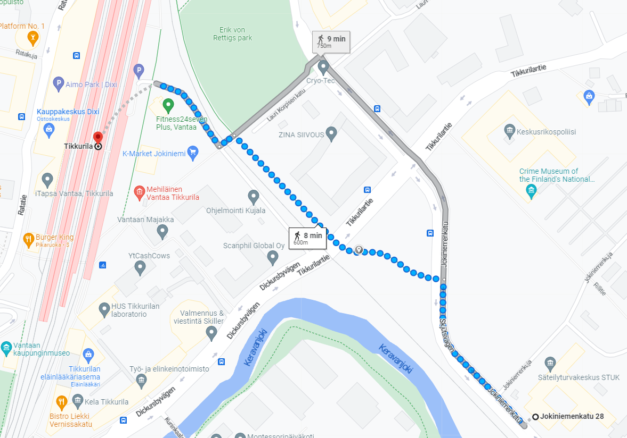
STUK, main entrance
Train station Tikkurilarila

Hotels

Hotels in Tikkurila
Hotelli Tikkurila  - 1,9 km to STUK  Address & Google Maps:  Läntinen Valkoisenlähteentie 52, 01300 Vantaa  www.hotellitikkurila.fi | 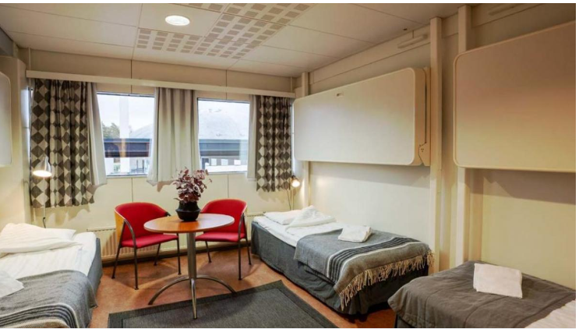
Original Sokos Hotel Vantaa  (situated in Tikkurila right next to the Tikkurila train station)  - 1 km to STUK  Address & Google Maps:  Hertaksentie 2, 01300 Vantaa  www.sokoshotels.fi/en/vantaa/sokos-hotel-vantaa | 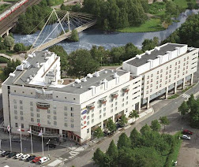
Forenom Aparthotel Vantaa Tikkurila  Tel. 020 1983420  - 650 meters to STUK  Address & Google Maps:  Väritehtaankatu 8, 01300 Vantaa  www.forenom.com/aparthotels/vantaa | 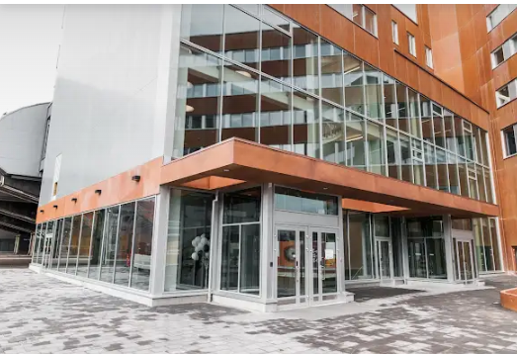
20 rooms  - 1,9 km to STUK  Address & Google Maps:  Kyläkaivontie 6 D, 01350 Vantaa  www.20rooms.fi/en/ | 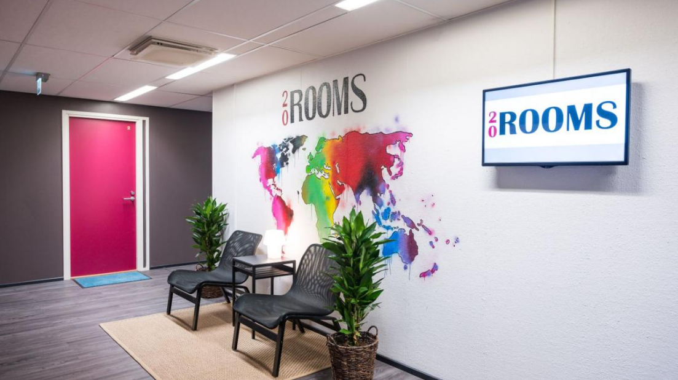
Lovely Mint Garden Studio  - 2,1 km to STUK  Address & Google Maps:  Minttutie 22b, 01300 Vantaa  www.booking.com/hotel/fi/lovely-mint-garden-studio.fi | 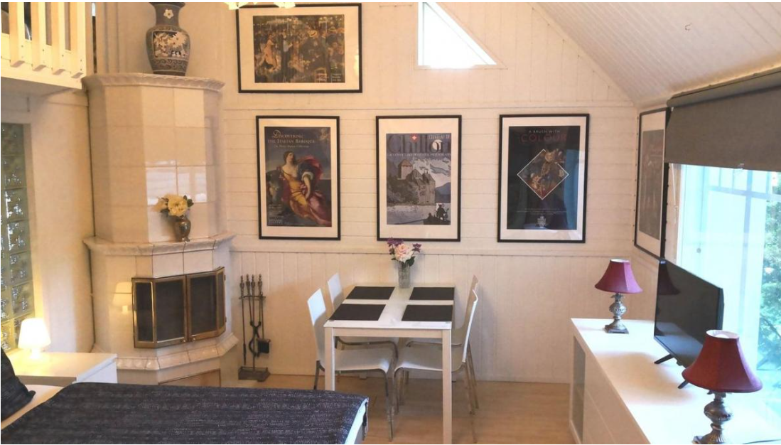

Hotels in Helsinki City Centre
www.myhelsinki.fi/see-and-do/accommodation
If you book a hotel from Helsinki City Centre, we recommend that you book a hotel with walking distance/easy connection to central railway station.

Other information

Helsinki Airport
www.finavia.fi/en/airports/helsinki-airport/airport/services-facilities

Taxi services at Helsinki Airport
www.finavia.fi/en/airports/helsinki-airport/airport/services-facilities/taxi-information?navref=serviceSearch

Transports

From the Airport to Tikkurila
There is a train connection from the airport to Tikkurila. The P train takes you to Tikkurila in 7 minutes; Tikkurila is the 3rd stop and then the train continues to Helsinki City Centre. Please note that there is also the I train from the airport to Helsinki City Centre but that does not go via Tikkurila. The trains operate almost on 24/7 basis except for a few hours around 1 - 5 AM (please check separately if needed).

During daytime there is a train every 10 minutes and early in the morning and late in the evening the interval rises to every 30 minutes. Tickets can be purchased from the ticket machines at the airport or via HSL Mobile Ticket app (see below for further information). You need to buy a BC-zone ticket which costs 3,10€. Train tickets cannot be bought onboard the trains.

You can also take a taxi from the airport to the hotel (which is about 8 km away). Taxi stations are front of Terminals 1 and 2. The taxis are operated by several different companies and the prices may vary accordingly (probably in the order of 15€) so you may need to pay attention like in many other cities.

We highly recommend using the train because of its convenience and low fixed price.

From Tikkurila to Airport
The I train takes you from Tikkurila to the airport. Timetables and tickets are the same as prescribed in the above.

The nearest taxi station is located beside the Tikkurila train station.

From Tikkurila to Helsinki City Centre
The most convenient way to travel to Helsinki City Centre is to take the train from Tikkurila. You can continue with the same P train you were using coming from the airport to Tikkurila, or you can use any of the trains: K, R, T, D or Z. The travelling time is 13 – 19 minutes, depending on the train. You need an ABC-zone ticket which costs 4,10€.

General info on travelling with the HSL-area (Helsinki, Vantaa, Espoo and several other surrounding cities)
There is a wide range of different means of public transportation (train, metro, trams, buses) expanding densely and widely around the Helsinki district. The same HSL-tickets can used but you need to follow the travel zones and buy your ticket accordingly. Further information on routes, travel zones, printable maps and timetables and different types of tickets, can found here: www.hsl.fi/en. An easy way for searching routes and buying corresponding tickets is to install the HSL Mobile Ticket app on your mobile phone: www.hsl.fi/en/tickets-and-fares/hsl-app.

Below is the plan of the trains. The airport is top in the middle and Tikkurila is on the right side in the middle within Zone C.

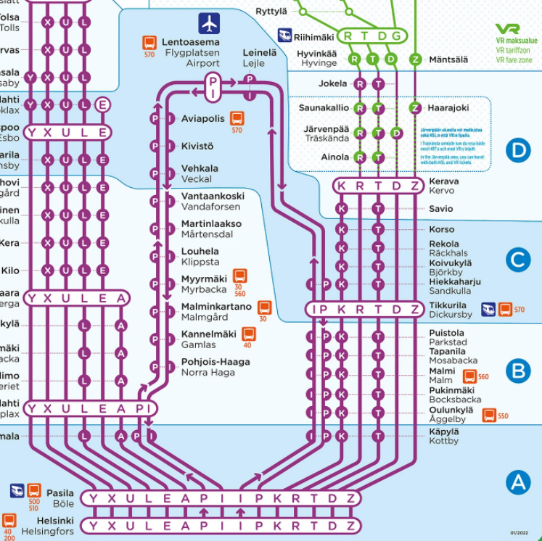

Restaurants and shops
Restaurants in Tikkurila: Google Maps info
Shopping centre Dixi (with a food market S-market 3rd floor) is located above Tikkurila railway station (dixi.fi), and also a smaller shopping center Tikkuri is nearby (www.tikkuri.fi).

Emergency and Health care
Emergency telephone number is 112. The call is free and is immediately served by the emergency centers that operate medical, police and fire systems, depending on the situation.

Nearest private health care stations Terveystalo (www.terveystalo.com/en/) and Mehiläinen (www.mehilainen.fi/en) are located in Tikkurila. Also public health care station is located in Tikkurila in address Kielotie 11 (Tikkurila health center), tel. +358 9 4191 1040.

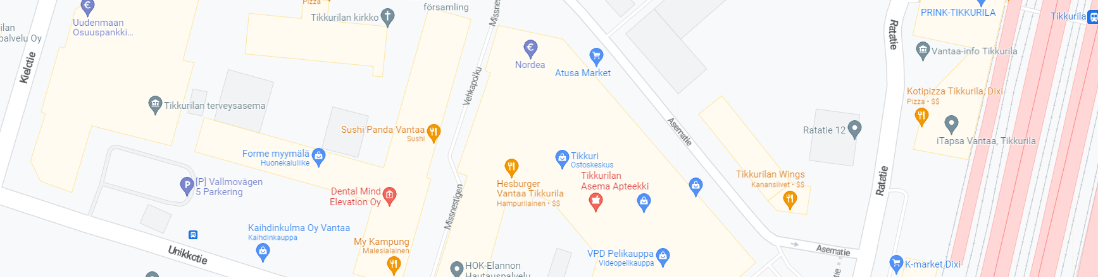
Tikkurila health center

COVID-19
Passengers entering Finland will no longer be required to present certificates of COVID-19 vaccination or tests. Most up-to-date information about COVID restrictions and entering Finland during the COVID-19 pandemic can be found from links below:

https://thl.fi/en/web/infectious-diseases-and-vaccinations/what-s-new/coronavirus-covid-19-latest-updates

https://thl.fi/en/web/infectious-diseases-and-vaccinations/what-s-new/coronavirus-covid-19-latest-updates/travel-and-the-coronavirus-pandemic

Currently there are no national recommendations on these.

Currency
Currency in Finland is euro. Credit/debit card payments are widely accepted. Cash can be withdrawn from ATMs and exchanged for instance at the airport.

Electricity
Finnish voltage is 230 volts, at the frequency of 50 hertz, following the European standards. The use of American standard plugs must be combined with a converter/adapter.

Pharmacies
Pharmacies in Tikkurila:
- Tikkurilan Ykkösapteekki
- Tikkurilan uusi apteekki
- Tikkurilan Asema Apteekki

https://www.google.com/maps/search/Apteekit/@60.2916703,25.0260664,14z/data=!3m1!4b1

Drinking water
Tap water is safe to drink. More information of the quality: Quality of drinking water - HSY

Weather
Finnish Meteorological Institute https://en.ilmatieteenlaitos.fi/

