**Programme GammaRay 2018, Reykjavik, 25-26 September 2018**

**Location:** [**CenterHotel Miðgarður**](https://www.google.com/maps/dir/Grand+H%C3%B3tel+Reykjav%C3%ADk,+Sigt%C3%BAn,+Reykjav%C3%ADk/64.1469208,-21.8887459/@64.1444497,-21.8942448,16.25z/data=!4m9!4m8!1m5!1m1!1s0x48d674c0baf92f69:0xa4c4d38cb761e7a4!2m2!1d-21.89156!2d64.14235!1m0!3e2)

Please show up at the informal get-together on Monday evening the 24th ([your way to there from Grand Hotel](https://www.google.com/maps/dir/Grand+H%C3%B3tel+Reykjav%C3%ADk,+Sigt%C3%BAn,+Reykjav%C3%ADk/64.1469208,-21.8887459/@64.1444497,-21.8942448,16.25z/data=!4m9!4m8!1m5!1m1!1s0x48d674c0baf92f69:0xa4c4d38cb761e7a4!2m2!1d-21.89156!2d64.14235!1m0!3e2))

| **Date** | **Start** | **End** | **Duration** | **Speaker** | **Title** |
| --- | --- | --- | --- | --- | --- |
| 25 | 09:00 | 09:15 | 00:15 |  | Registration |
| 25 | 09:15 | 09:30 | 00:15 |  | Opening and practical information |
| 25 | 09:30 | 10:15 | 00:45 | Iolanda Osvath, IAEA-MEL | *Invited lecture:* On the analysis of challenging ALMERA Proficiency Test samples |
| 25 | 10:15 | 10:45 | 00:30 | Coffee break |  |
| 25 | 10:45 | 11:30 | 00:45 | Michel Bruggeman, SCK-CEN | *Invited lecture:* Efficiency transfer for low-energy (30-100 keV) gamma-ray spectrometry analyses |
| 25 | 11:30 | 13:00 | 01:30 | Lunch |  |
| 25 | 13:00 | 13:20 | 00:20 | Nikola Markovic, DTU Nutech | Activity standardization by γ-γ coincidence methods |
| 25 | 13:20 | 13:40 | 00:20 | Kara Phillips, Mirion Technologies Inc. | Correlation Effects in Gamma Spectroscopy Efficiency Calibrations and their Impact on Activity and Uncertainty Quantification |
| 25 | 13:40 | 14:00 | 00:20 | Linda Corneliusson, Ringhals, Vattenfall | Sn-117m or Te-123m? |
| 25 | 14:00 | 14:20 | 00:20 | Roy Pöllänen, STUK | Recent RTD-activities on gamma-ray spectrometry in STUK |
| 25 | 14:20 | 14:40 | 00:20 | Jani Turunen, STUK | RADICAL – New research project at STUK |
| 25 | 14:40 | 15:10 | 00:30 | Coffee break |  |
| 25 | 15:10 | 15:30 | 00:20 | Sven Nielsen, DTU Nutech | Recent check of calibration across detectors |
| 25 | 15:30 | 15:50 | 00:20 | Sune Juul Krogh, DEMA | Experiences from CONTEX 2018 |
| 25 | 15:50 | 16:00 | 00:10 |  | Announcements and information |
| 25 | 19:30 |  |  | Seminar dinner in Reykjavik | Austurlandahraðlestin (<https://www.hradlestin.is/groupmenus>)  ([Your way to there from Grand Hotel](https://www.google.com/maps/dir/Grand+H%C3%B3tel+Reykjav%C3%ADk,+Sigt%C3%BAn,+Reykjav%C3%ADk/Austurlandahra%C3%B0lestin,+Reykjav%C3%ADk/@64.1450699,-21.9235162,15z/data=!4m15!4m14!1m5!1m1!1s0x48d674c0baf92f69:0xa4c4d38cb761e7a4!2m2!1d-21.89156!2d64.14235!1m5!1m1!1s0x48d60b2d608ad3cd:0xdaa29ec10d5ba8ff!2m2!1d-21.937963!2d64.1464331!3e2!5i2)) |
| **Day 2** |  |  |  |  |  |
| 26 | 09:00 | 09:20 | 00:20 | Marc Breidenbach, AMETEK GmbH | LVis – a GUI for ORTEC’s GammaVision that simplifies TCS correction and efficiency transfer using (M)EFFTRAN |
| 26 | 09:20 | 09:40 | 00:20 | Jacobus Andreas Swartz, DTU Nutech | Gamma-ray spectroscopy with modern scintillation crystals and Silicon Photomultipliers |
| 26 | 09:40 | 10:00 | 00:20 | Henrik Ramebäck, FOI | A Monte Carlo Method for uncertainty calculation in gamma spectrometry |
| 26 | 10:00 | 10:30 | 00:30 | Coffee break |  |
| 26 | 10:30 | 10:50 | 00:20 | Anna Rand, IFE | Results of the sediment samples |
| 26 | 10:50 | 11:10 | 00:20 | Tim Vidmar, SCK-CEN | Sensitivity of TCS correction factors to uncertainty in the computed total efficiency |
| 26 | 11:10 | 11:30 | 00:20 | Thomas B. Aleksandersen, Statens Strålevern | CONTEX 2018: UAVs and gamma spectrometry |
| 26 | 11:30 | 13:00 | 01:30 | Lunch |  |
| 26 | 13:00 | 13:20 | 00:20 | Trygve Bjerk, IFE  Nikola Markovic, DTU Nutech | Intercomparison on identification of radionuclides in low- and high-resolution gamma spectra |
| 26 | 13:20 | 13:40 | 00:20 | Antti Kallio, STUK | Analysis of natural series using UniSampo-Shaman –considerations and case studies |
| 26 | 13:40 | 14:10 | 00:30 | Coffee break |  |
| 26 | 14:10 | 14:40 | 00:30 | Participant feedback survey |  |
| 26 | 14:40 | 15:10 | 00:30 | Seminar round up, future gamma spectrometry meetings |  |
| 26 | 15:10 |  |  | End of Seminar |  |

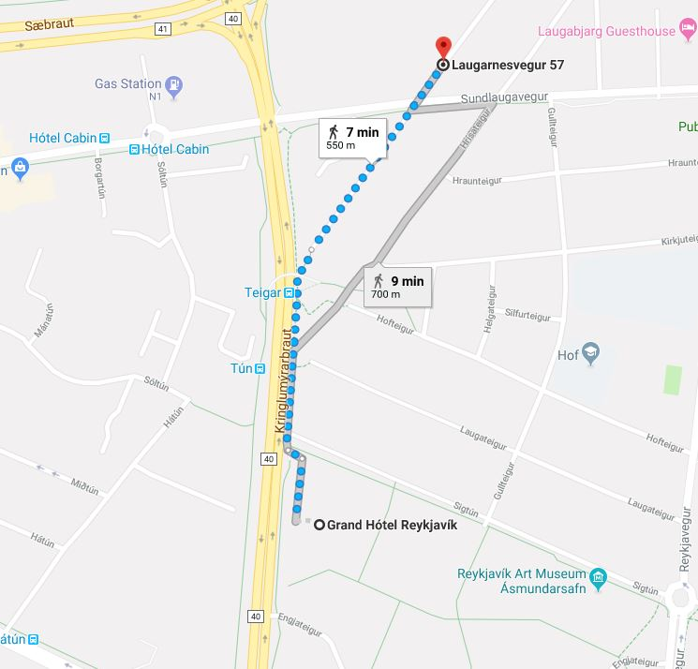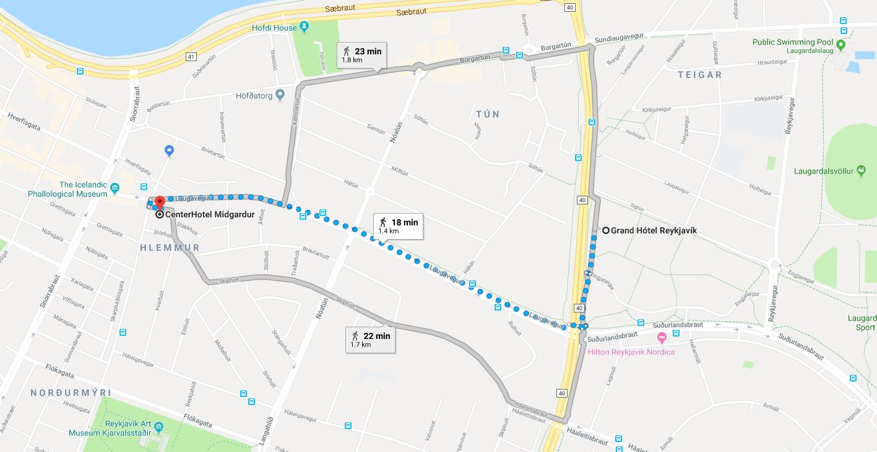

24 September: Get together at 19:30, Laugarnesvegur 57

(64° 8'49.00"N 21°53'20.00"W)

25-26 September: Getting from Grand Hotel to the workshop venue at CenterHotel Miðgarður

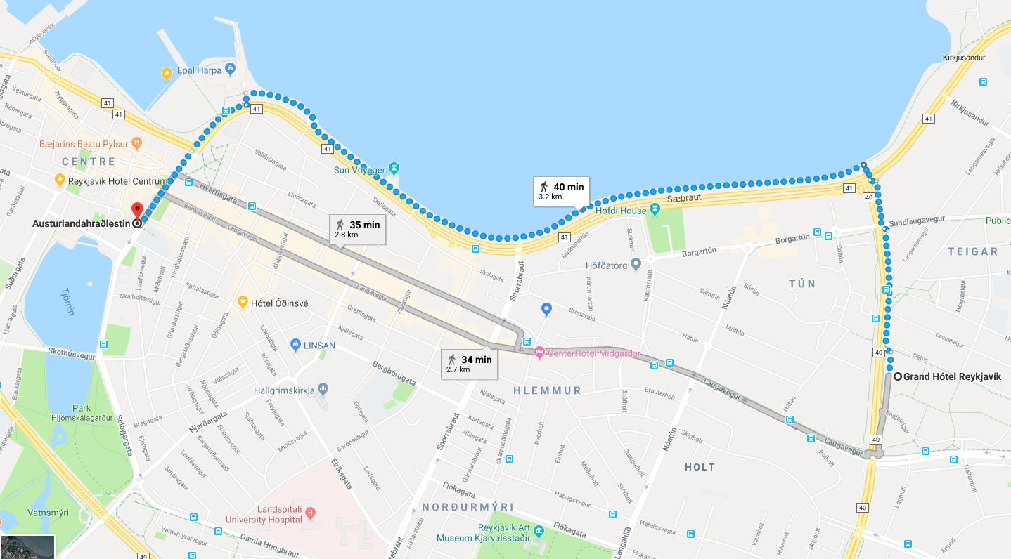

Getting from Grand Hotel to dinner at Austurlandahraðlestin, Lækjargata 8.

If the weather is OK, a stroll along the seaside is recommended.