Transports

From the airport to Tikkurila railway station

There is a train connection from the airport to Tikkurila (Figs. 2-3). The P train takes you to Tikkurila in 7 minutes; Tikkurila is the 3rd stop and then the train continues to Helsinki City Centre. Please note that there is also the I train from the airport to Helsinki City Centre but that does not go via Tikkurila. The trains operate almost on 24/7 basis except for a few hours around 1 - 5 AM (please check separately if needed). During daytime there is a train every 10 minutes and early in the morning and late in the evening the interval rises to every 30 minutes. Tickets can be purchased from the ticket machines at the airport or via HSL Mobile Ticket app (see below for further information). You need to buy a BC-zone ticket which costs around 3€. Train tickets cannot be bought onboard the trains.

You can also take a taxi from the airport to the Original Sokos Hotel Vantaa (which is about 8 km away). Taxi stations are front of Terminals 1 and 2. The taxis are operated by several different companies and the prices may vary accordingly (probably in the order of 15€) so you may need to pay attention like in many other cities.

We highly recommend using the train because of its convenience and low fixed price.

From Tikkurila to Airport

The I train takes you from Tikkurila to the airport. Timetables and tickets are the same as prescribed in the above.

The nearest taxi station is located beside the Tikkurila train station (near the hotel).

To Helsinki City Centre from Tikkurila

The most convenient way to travel to Helsinki City Centre is to take the train from Tikkurila. You can continue with the same P train you were using coming from the airport to Tikkurila, or you can use any of the trains: K, R, T, D or Z. The travelling time is 13 – 19 minutes, depending on the train. You need an ABC-zone ticket which costs around 4€.

General info on travelling with the HSL-area (Helsinki, Vantaa, Espoo and several other surrounding cities)

There is a wide range of different means of public transportation (train, metro, trams, buses) expanding densely and widely around the Helsinki district. The same HSL-tickets can used but you need to follow the travel zones and buy your ticket accordingly. Further information on routes, travel zones, printable maps and timetables and different types of tickets, can found here: https://www.hsl.fi/en. An easy way for searching routes and buying corresponding tickets is to install the HSL Mobile Ticket app on your mobile phone: https://www.hsl.fi/en/tickets-and-fares/hsl-app.

Below is the plan of the trains (Fig.1). The airport is top in the middle and Tikkurila is on the right side in the middle within Zone C.

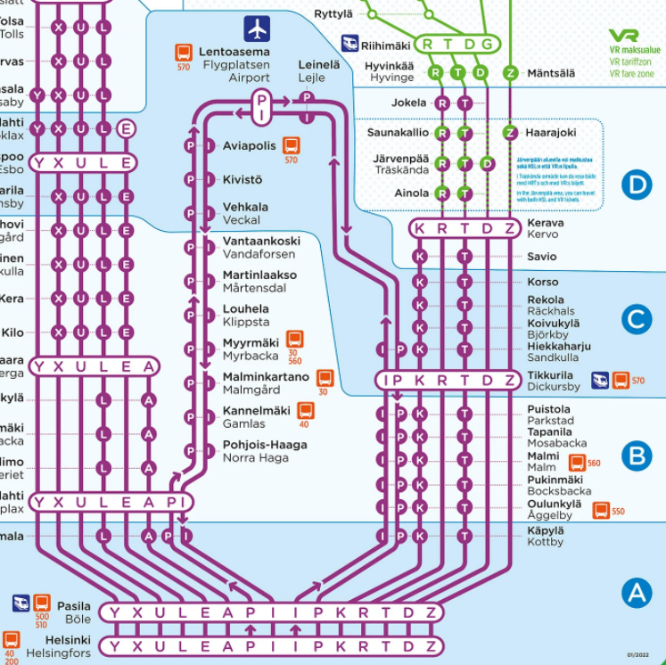

Fig. 1. Plan of the trains.
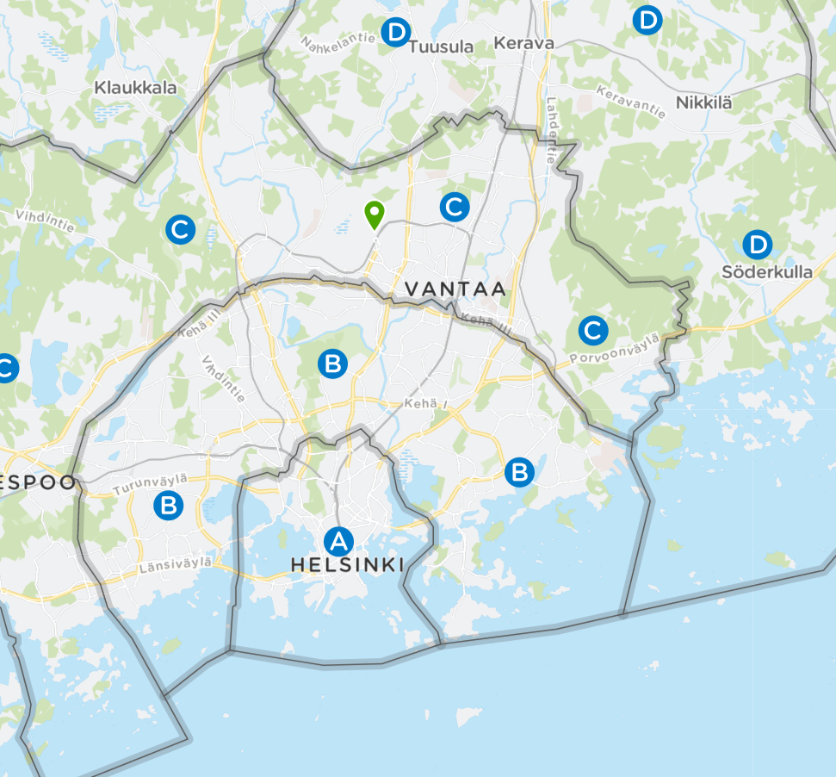
STUK
Airport
Fig. 2. Representation of the zones with different fees (letters A – D in a blue sphere). The route of trains (here thin grey line) is hardly visible, but you can see green Airport symbol and location of STUK (red sphere) and hotel Vantaa (pink sphere). Best way from Airport to STUK (Tikkurila railway station) is by using P train. Please note that if your hotel is in Helsinki, all trains from the airport (not depending on the direction) finally goes to the main railway station of Helsinki.

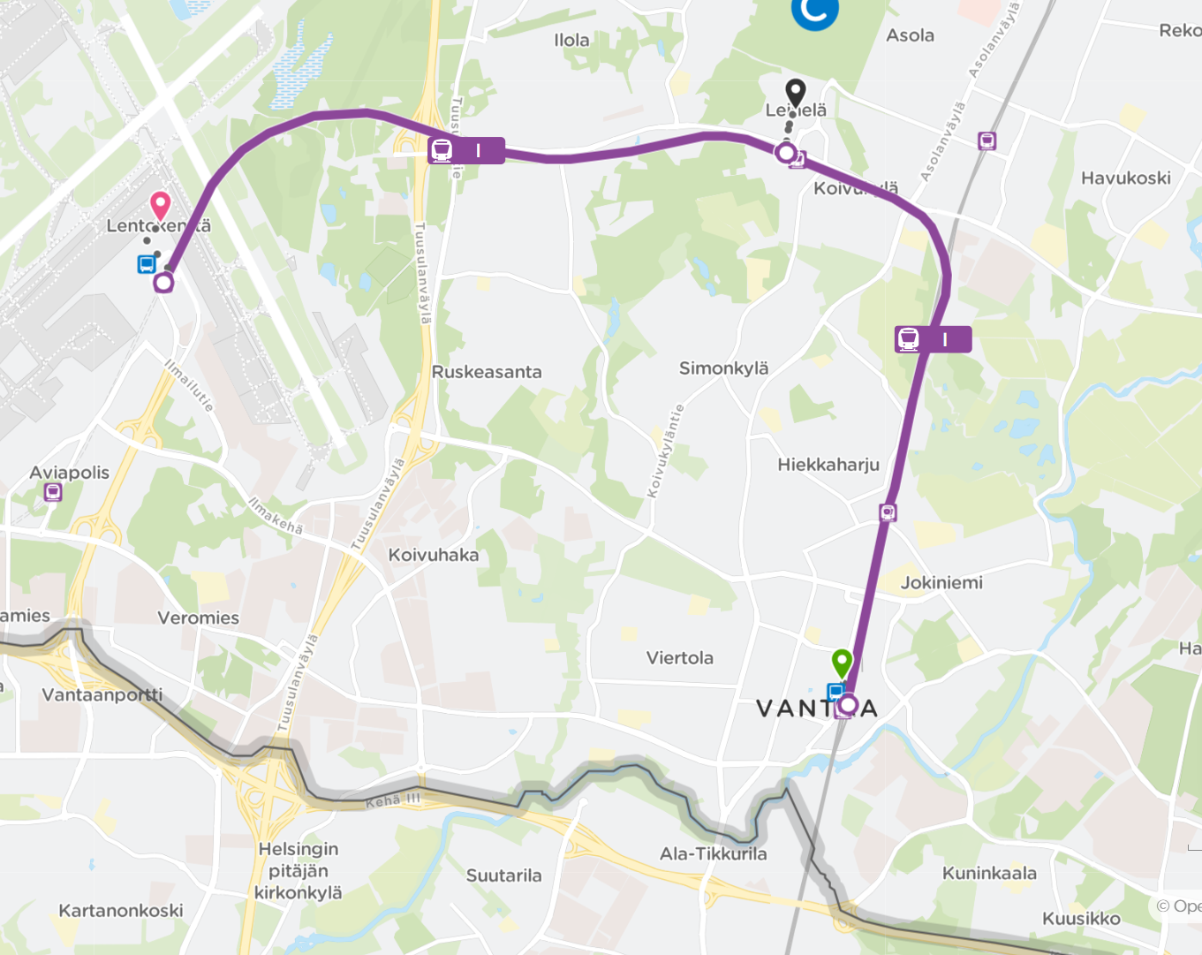
STUK
Fig. 3. Zoom to the route of P train from Airport (Lentokenttä in finnish) to Tikkurila railway station. It takes around 7 min to go to the Tikkurila station. Hotel Vantaa (if you select that hotel) is located nearby the station.

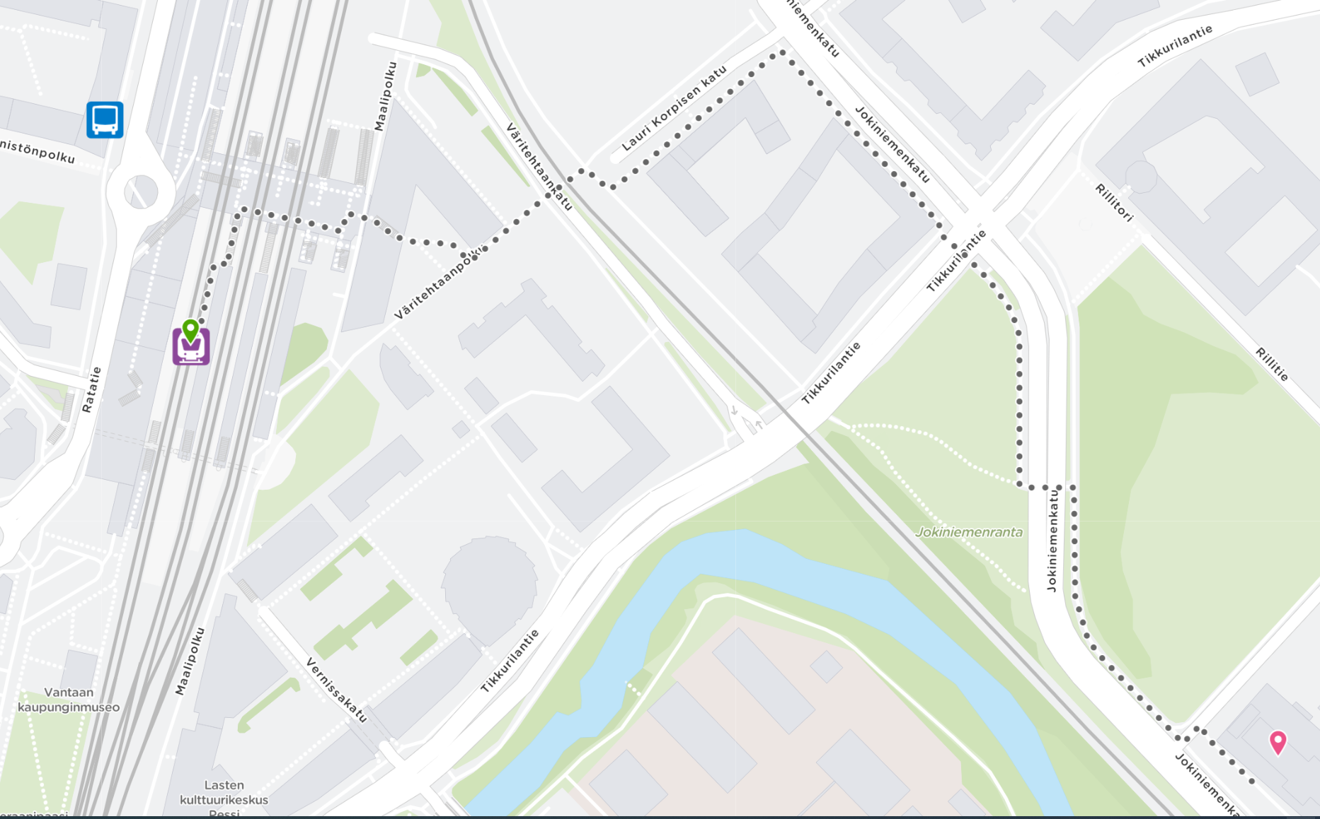
STUK
Fig. 4. There is no public traffic from Tikkurila train station to STUK, but the distance is only 700-800 m. So, walking is the best option. It takes only 10-15 min. You can follow the red spots shown in the figure.

